SOURCE CODE MANAGEMENT



FILE

**Submitted To:**

Dr. Sharad Chauhan

**Submitted By:**

Varnika Som

2210990951

G-30(A)



**Source Code Management File**

Subject Name: **Source Code Management (SCM)**

Subject Code: **22CS003**

Cluster: **Beta**

**Submitted By:**

**Name: Varnika Som**

**Roll No. : 2210990951**

**Group: 30-A**

**Task 1.1 Submission** (Week 4)

1. Setting up of Git Client
2. Setting up of GitHub Account
3. Generate logs
4. Create and visualize branches
5. Git lifecycle description

**INDEX**

**List Of Programs**

|  |  |  |  |
| --- | --- | --- | --- |
| **S. No.** | **Program Title** | **Page No.** | **Signature** |
| 1 | Setting up of Git client | 4 - 6 |  |
| 2 | Setting up GitHub Account | 7 - 8 |  |
| 3 | Generate logs | 9 - 10 |  |
| 4 | Create and visualize branches | 11 - 13 |  |
| 5 | Git Lifecycle Description | 14 - 15 |  |

# Experiment 1

**Aim:** Setting up of Git Client

## Theory:

GIT: It’s a Version Control System (VCS). It is a software or we can say a server by which we are able to track all the previous changes in the code. It is basically used for pushing and pulling of code. We can use git and git-hub parallelly to work with multiple members or individually. We can make, edit, recreate, copy or download any code on git hub using git.

**Procedure:** We can install Git on Windows, using the most official build which is available for download on the GIT’s official website or by just typing (scm git) on any search engine. We can go on <https://git-scm.com/download/win>and can select the platform and bit-version to download. And after clicking on your desired bit-version or ios it will start downloading automatically.

## Snapshots of download:

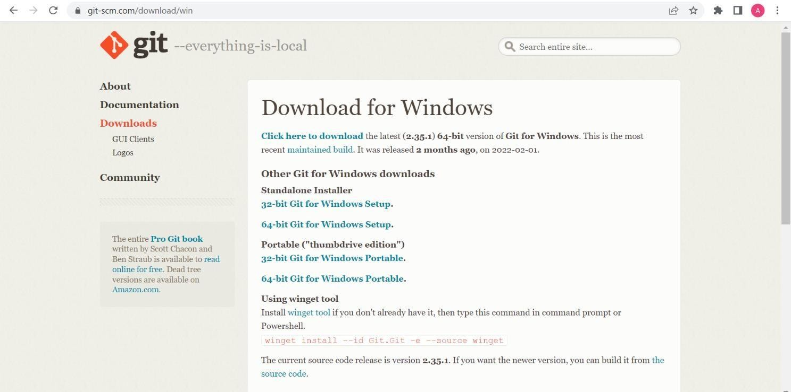

Opted for “64-bit Git for Windows Setup”

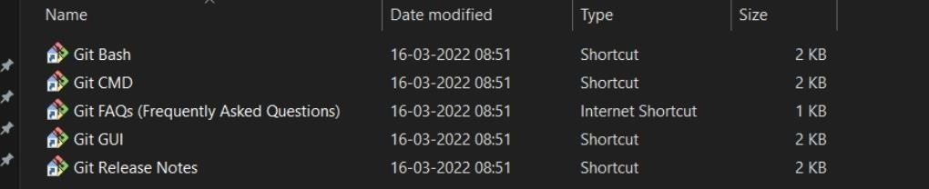

Git and its files in downloads

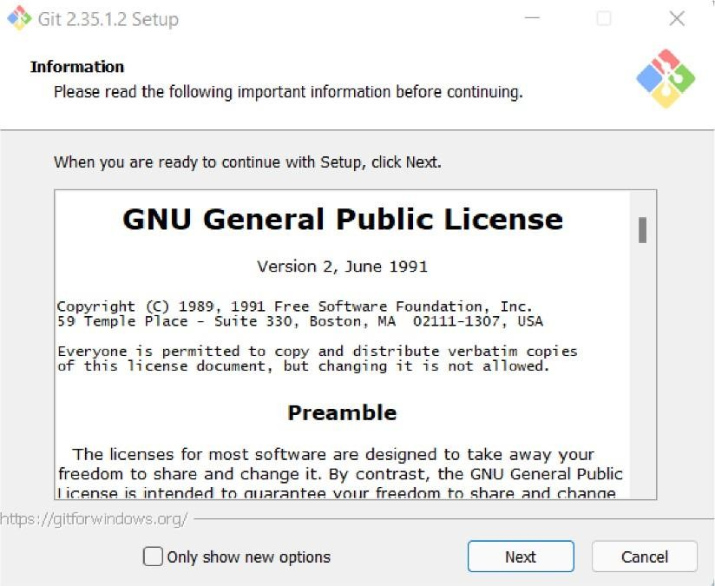

Git Setup

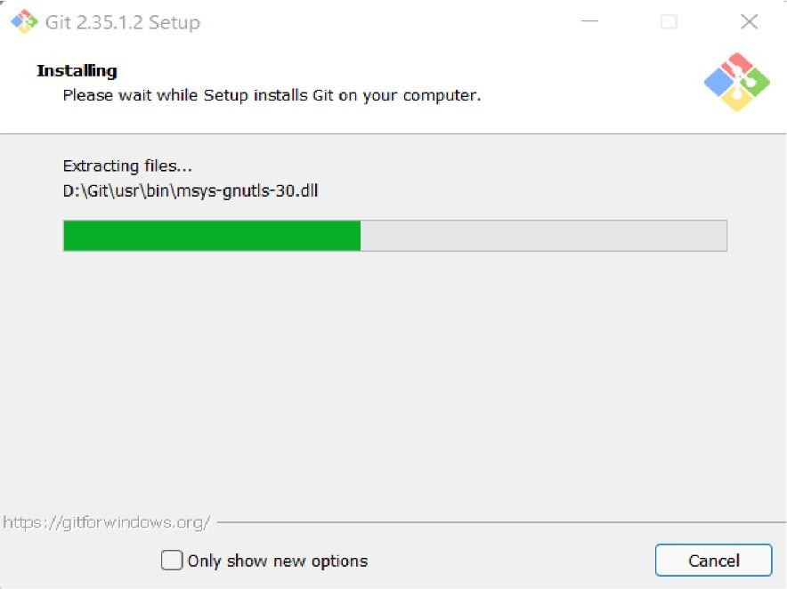

Git Installation

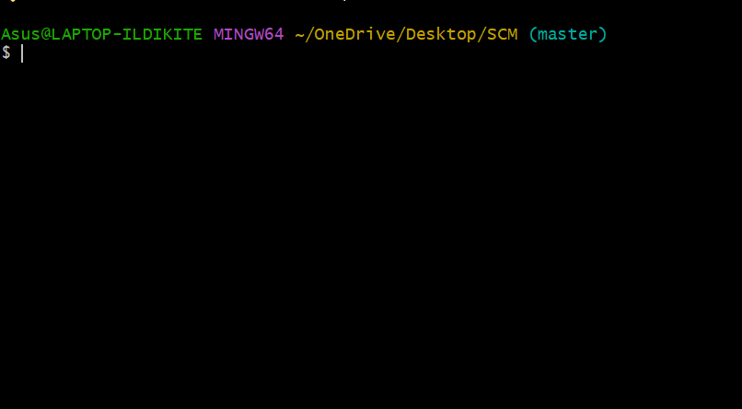

Git Bash Launched



# Experiment 2

**Aim:** Setting up GitHub Account

## Theory:

GitHub: GitHub is a website and cloud-based service (client) that helps an individual or developers to store and manage their code. We can also track as well as control changes to our or public code.

Advantages of GitHub: GitHub has a user-friendly interface and is easy to use.We can connect the git-hub and git but using some commands shown below in figure

01. Without GitHub we cannot use Git because it generally requires a host and if we are working for a project, we need to share it will our team members, which can only be done by making a repository. Additionally, anyone can sign up and host a public code repository for free, which makes GitHub especially popular with open-source projects.

## Procedure:

To make an account on GitHub, we search for GitHub on our browser or visit <https://github.com/signup>. Then, we will enter our mail ID and create a username and password for a GitHub account.

## Snapshots –



After visiting the link this type of interface will appear, if you already have an account, you can sign in and if not, you can create.

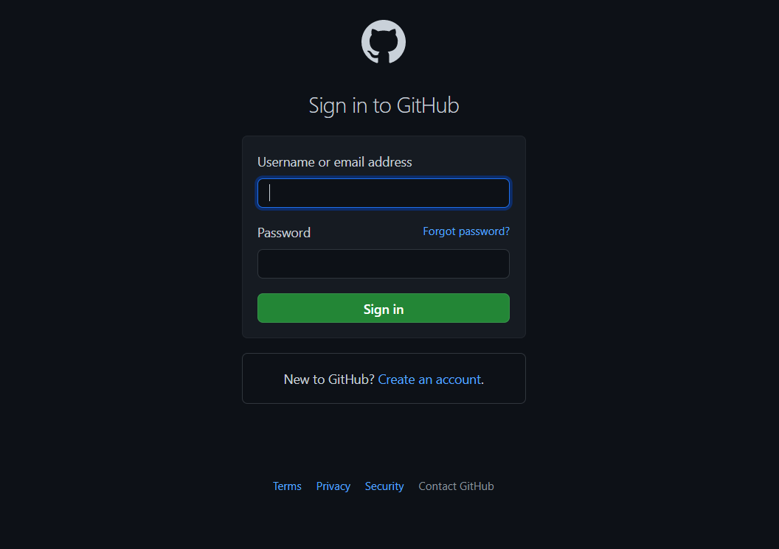

GitHub Login

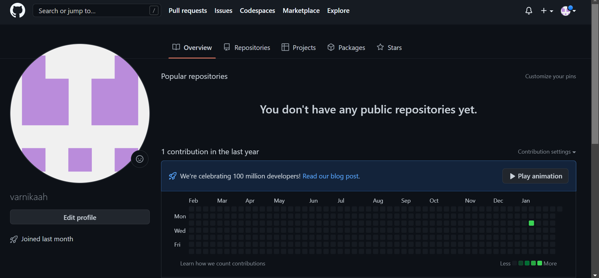

GitHub Interface



# Experiment 3

**Aim:** Program to Generate log

## Theory:

Logs: Logs are nothing but the history which we can see in git by using the code git log.

It contains all the past commits, insertions and deletions in it which we can see any time. Logs helps to check that what were the changes in the code or any other file and by whom. It also contains the number of insertions and deletions including at which time it was changed.

## Procedure:

First of all, create a local repository using Git. For this, you have to make a folder in your device, right click and select “Git Bash Here”. This opens the Git terminal. To create a new local repository, use the command “git init” and it creates a folder “.git”.

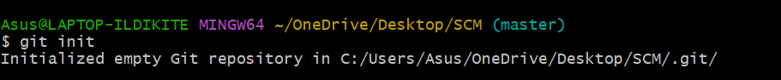

When we use GIT for the first time, we have to give the user name and email so that if I am going to change in project, it will be visible to all.

For this, we use command:

“git config --global user.name Name” “git config --global user.email email”

For verifying the user’s name and email, we use: “git config --global user.name”

“git config --global user.email”

Some Important Commands

* ls → It gives the file names in the folder.
* ls -lart → Gives the hidden files also.
* git status → Displays the state of the working directory and the staged snapshot.
* touch filename → This command creates a new file in the repository.
* Clear → It clears the terminal.
* rm -rf .git → It removes the repository.
* git log → displays all of the commits in a repository's history
* git diff → It compares my working tree to staging area.

Git status:

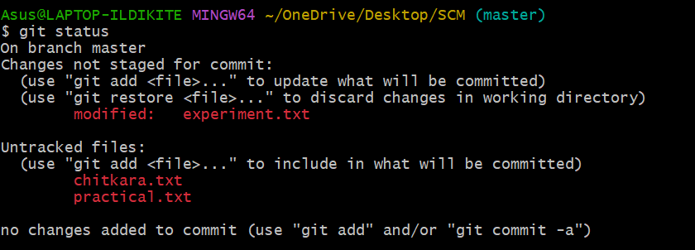

Git log:

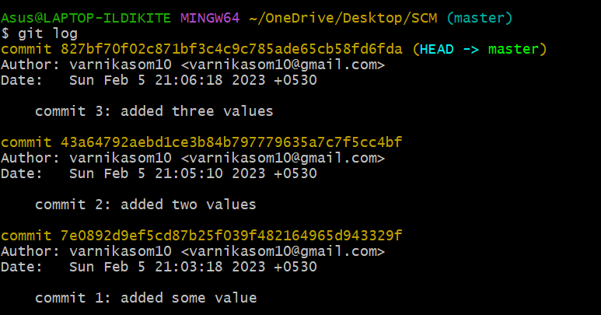

The git log command displays a record of the commits in a Git repository. By default, the git log command displays a commit hash, the commit message and other commit metadata.

Git log oneline

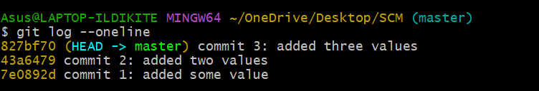

# Experiment 4

**Aim:** Create and visualize branches

## Theory:

Branching: A branch in Git is an independent line of work (a pointer to a specific commit). It allows users to create a branch from the original code (master branch) and isolate their work. Branches allow you to work on different parts of a project without impacting the main branch.

Create branches: The main branch in git is called as master branch. But we can make branches out of this main master branch. All the files present in master can be shown in branch but the file which are created in branch are not shown in master branch. We can also merge both the parent (master) and child (other branches).

Syntax:

For creating a new branch, git branch name by default is master branch.

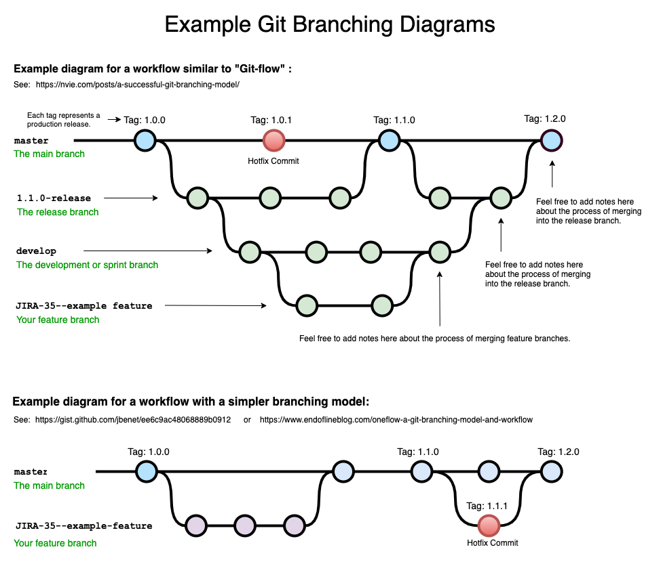

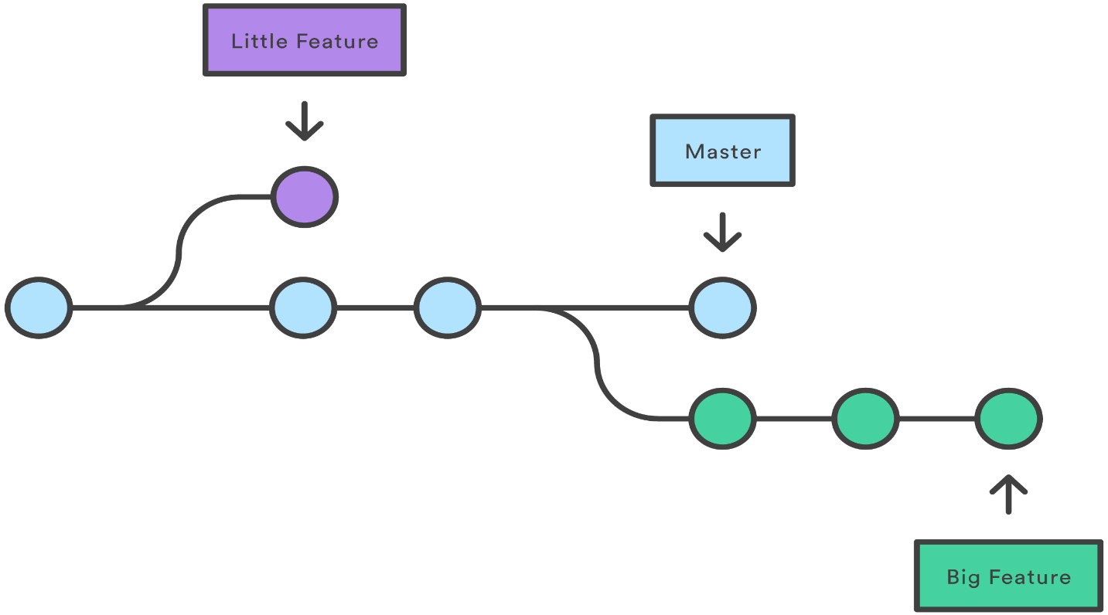

## Snapshots –

Default branch is master branch

o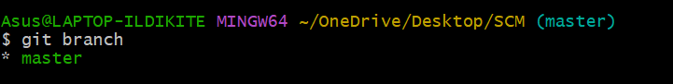

Adding a scm branch



Switching to scm branch

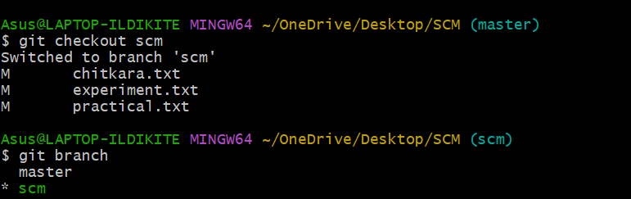

Git log (before merging the branches)

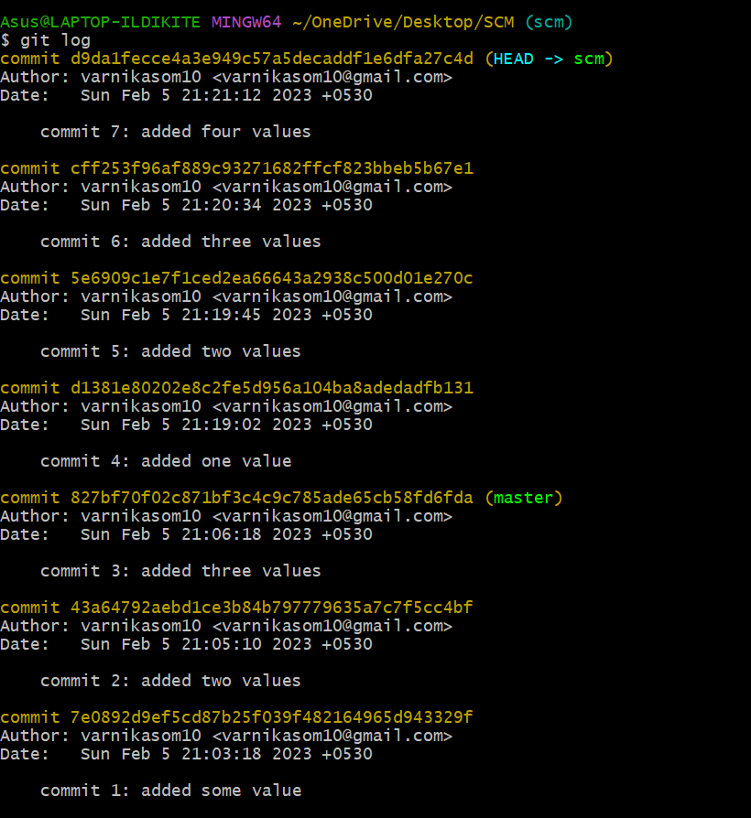

Git log --oneline

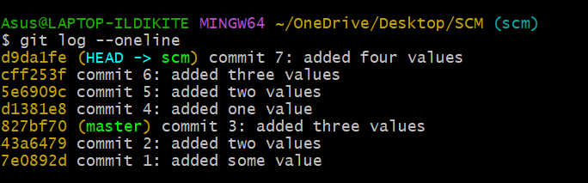

Switching to master branch

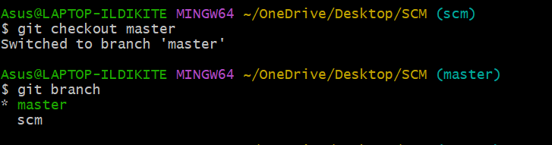

Merging the scm branch with master branch

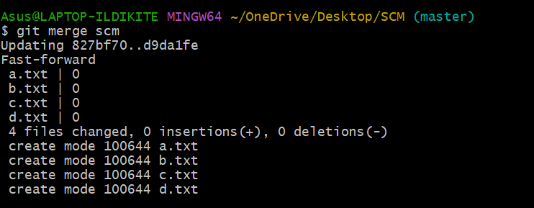

Git log(After merging the branches)

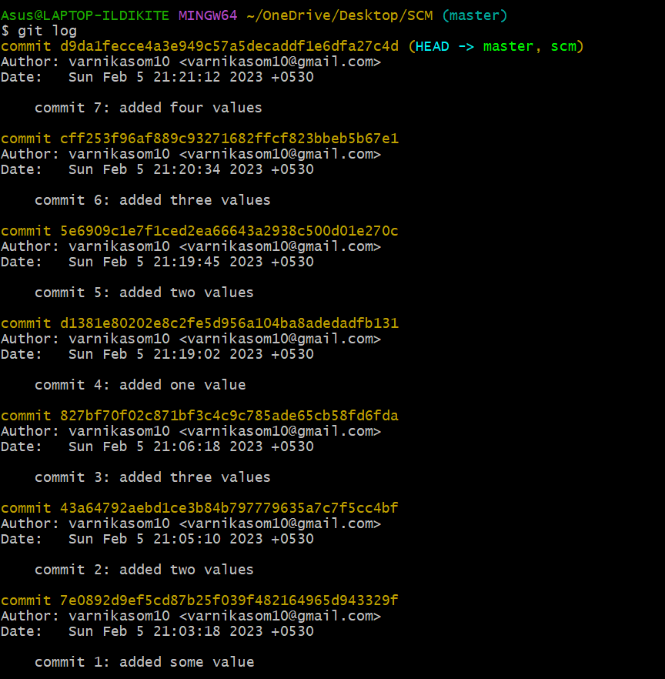

Deleting a branch

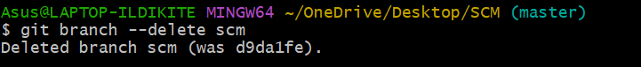



# Experiment 5

**Aim:** Git lifecycle description

## Theory:

Stages in GIT Life Cycle: Files in a Git project have various stages like Creation, Modification, Refactoring, and Deletion and so on. Irrespective of whether this project is tracked by Git or not, these phases are still prevalent. However, when a project is under Git version control system, they are present in three major Git states in addition to these basic ones. Here are the three Git states:

* Working directory
* Staging area
* Git directory

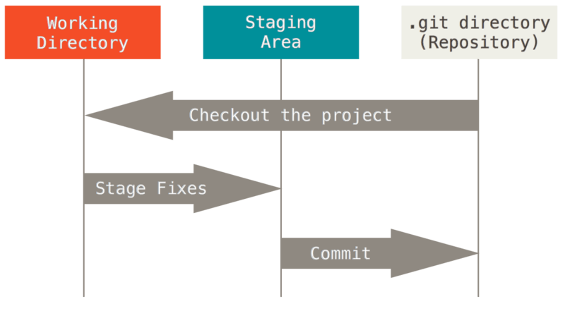

## Working Directory:

Whenever we want to initialize our local project directory to make it a git repository, we use the git init command. After this command, git becomes aware of the files in the project although it doesn’t track the files yet. The files are further tracked in the staging area.

## Staging Area:

Staging area is the playground where you group, add and organize the files to be committed to Git for tracking their versions.

## Git Directory:

Now since we have all the files that are to be tracked and are ready in the staging area, we are ready to commit our files using the git commit command. Commit helps us in keeping the track of the metadata of the files in our staging area. We specify every commit with a message which tells what the commit is about. Git preserves the information or the metadata of the files that were committed in a Git Directory which helps Git in tracking files and basically it preserves the photocopy of the committed files. Commit also stores the name of the author who did the commit, files that are committed, and the date at which they are committed along with the commit message.

**Remote Repository:** It means mirror or clone of the local Git repository in GitHub. And pushing means uploading the commits from local Git repository to remote repository hosted in GitHub.

